Name:………………………………………………………………………………………………………………

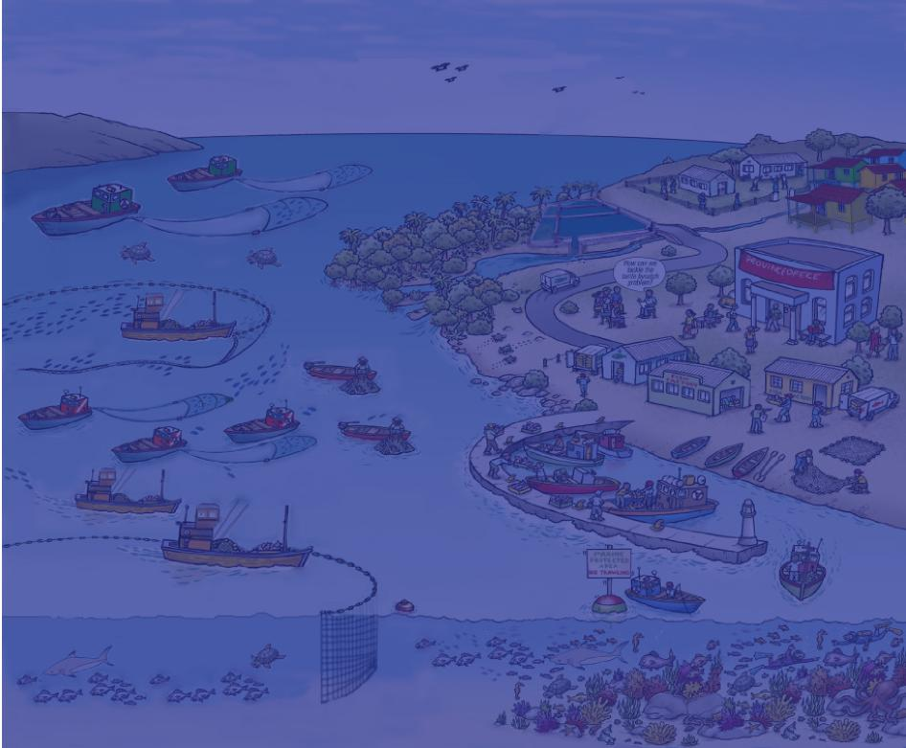
(Ecosystem Approach to Fisheries Management)
Essential EAFM
WORKBOOK
Version 1
Date:………...……………………………… Place………………………………………………………………………… .

Essential EAFM Participant Workbook
☺ How to use this workbook
You will work in groups for much of this course, and you will mostly be using cards, pens and paper for group work. It is VERY IMPORTANT that you record all the outputs from your group work. Use the relevant sections of this workbook to write your notes. You will need to refer to many of your outputs for finalizing your draft EAFM plan which you will present on day 5.
This workbook covers the following phases and steps:
Module number | Step/ phase | Activity/group work | Workbook  page  number
5 |  | Review EAFM continuum for individual fishery and plot for local or country fishery | 4
5 |  | Identify challenges and opportunities in moving towards EAFM | 5
8 | Startup A | List all FMU stakeholders; plot them onto importance/ influence matrix | 6-7
8 | Startup A | Plot your FMU stakeholder linkages/relationships | 8
10 | Step 1.1 | Define your FMU | 9
10 | Step 1.2 | Agree the FMU vision | 9
10 | Step 1.3 | Identify type of information needed for scoping FMU | 10
11 | Step 2.1 | Identify threats and issues for your FMU | 11
11 | Step 2.2 | Prioritize through risk assessment | 12
11 | Step 2.3 | Develop FMU goals | 13
12 | Reality Check I | Brainstorm constraints and opportunities to achieving these goals | 13
12 | Reality Check I | Win-win conflict resolution | 14
13 | Step 3.1 | Develop operational objectives | 15
13 | Step 3.2 | Select indicators and benchmarks for objectives | 16
14 | Step 3.3 | Agree management actions and compliance | 17
14 | Step 3.4 | Agree financing mechanisms | 18
14 | Step 3.5 | Finalize draft EAFM plan | 19
15 | Step 4.1 | Implementation | 20
15 | Step 4.1 | Formalize, communicate and engage | 21
16 | Reality Check II | Revisit constraints and opportunities to achieving your FMU goals | 22
17 | Step 5 | Performance review template | 23-24

Essential EAFM Participant Workbook

EAFM plan for FMU XXXX
- VISION
The broad goal of management.
- BACKGROUND
Description of the area and resources to be managed, including maps at different scales.
The fisheries management area
Area of operation of the fishery, jurisdictions and ecosystem "boundaries" (including national/province/district
jurisdictions). Map of FMU.
History of fishing and management
Brief description of the past development of the fishery in terms of fleets, gear, people involved, etc.
Current status of the fishery
Description of the fishery resources and fleet/gears used;
Resource status;
Map of resource use patterns.
Socio-economic benefits, including postharvest
Description of stakeholders and their interests (including socio-economic status);
Description of other uses/users of the ecosystem, especially activities that could have major impacts and
arrangements for coordination and consultation processes;
Social and economic benefits, both now and in the future.
Special environmental considerations
Details of critical environments, particularly sensitive areas and endangered species.
Institutional aspects
Legislative background;
Existing co-management arrangements – roles and responsibilities;
MCS arrangements;
Consultation process leading to the plan and on-going activities;
Details of decision-making process, including recognized participants;
Nature of rights granted in the fishery and details of those holding the rights;
Maps of management interventions/user rights/jurisdiction boundaries.
- MAJOR THREATS AND ISSUES
Ecological issues
Fisheries resources and general environmental issues, including both the impact of the fishery on the environment
and vice versa.
Social and economic issues
Issues relating to the people involved in fishing, the general public and at the national level, including gender issues.
Governance issues
Issues affecting the ability to achieve the management objectives.
- GOALS OF MANAGEMENT
Higher level goals, i.e. the ultimate goal of management.
- OBJECTIVES, INDICATORS AND BENCHMARKS
Priority issues, objectives, benchmarks for the fishery, covering:
- fishery resources;
- environment (including by catch, habitats, prey protection, biodiversity, etc.);
- social;
- economic;
- governance (ability to achieve the plan).
- MANAGEMENT ACTIONS
Agreed actions for the plan to meet all objectives within an agreed time frame, including by-catch, habitat protection,
socio-economic benefits, good governance, etc.
- COMPLIANCE
For actions that require rules/regulations - arrangements for ensuring that the management actions are effective.
- DATA AND INFORMATION NEEDS
Data and information needs to monitor implementation of the plan. Clarify where the data are to be found and who
collects, analyses and uses the information.
- FINANCING
Major sources of funding.
- REVIEW OF THE PLAN
Date and nature of next review(s) and audit of performance of management.

Essential EAFM Participant Workbook
1. Moving towards EAFM continuum: complete this table for your fishery/fisheries

To what extent are EAFM principles being applied in your fishery? Plot your fishery on a scale of 0-5 (where 0 = none; and 5 = excellent)

EAFM principles | 0 ………………………………………………………………………………..………………...…5
- Good governance | …………………………………………………………………………………………..>
- Appropriate scale | ………………….……………………………………………………………………….>
- Increased participation | ……………………………………………………………………………………………>
- Multiple objectives | ……………………..…………………………………………………………………….>
- Cooperation and coordination | ……………………………………………………………………………………………>
- Adaptive management | ……………………………………………………………………………………………>
- Precautionary approach | ……………………………………………………………………………………………>

Essential EAFM Participant Workbook
Moving towards EAFM
Identify challenges in moving towards EAFM

Identify opportunities in moving towards EAFM

Essential EAFM Participant Workbook
Startup A
List the major FMU stakeholders

Essential EAFM Participant Workbook
Startup A
Plot the stakeholders onto the importance/influence matrix
High importance/Low influence | High importance/High influence
Low importance/Low influence | Low importance/Low influence

Essential EAFM Participant Workbook
Startup A
Plot your FMU stakeholder linkages/relationships (Venn diagram)

Essential EAFM Participant Workbook
Step 1.1
Define your FMU
Step 1.2
Agree the FMU vision

Essential EAFM Participant Workbook
Step 1.3
Identify type of information needed for scoping the FMU

Essential EAFM Participant Workbook
Step 2.1
Identify threats and issues for your FMU

Essential EAFM Participant Workbook
Step 2.2
Prioritize issues through a risk assessment

Essential EAFM Participant Workbook
Step 2.3
Develop FMU goals

Reality Check I

Constraints and opportunities that may prevent you to achieve your FMU goals

Essential EAFM Participant Workbook

WIN-WIN CONFLICT RESOLUTION WORKSHEET
1. The partnership frame: "let's find a way to solve this that works for everyone" |  | - Brainstorm  - Evaluate solutions  - Choose solutions
2. Define problem in terms of needs/outcomes...
Person A: | Person B: | Solution 1
Original solution: | Original solution:
Basic needs/outcome: | Basic needs/outcome
 |  | Solution 2
 |  | Solution 3
 |  | Solution 4
 |  | Solution 5
Shared (relationship) needs:
- Plan action |  | - Evaluate results:

Essential EAFM Participant Workbook
Step 3.1
Develop operational objectives

Essential EAFM Participant Workbook
Step 3.2
Select indicators and benchmarks for the objectives

Essential EAFM Participant Workbook
Step 3.3
Agree on management actions

Essential EAFM Participant Workbook
Step 3.4
Agree on data and information needs and financing mechanisms

Essential EAFM Participant Workbook
Step 3.5: Now you have all the information to finalize the draft EAFM plan.

Essential EAFM Participant Workbook
Step 4.1 Implementation
Implementation work plan template
Management action:
What management actions are currently being used:
EAFM plan objectives that will be addressed with this management action:
What | Agency responsible (who) | When | Where | Other issues
What specific tasks need to be done? | - Nominate what agency is responsible for monitoring, reporting and MCS.  - State the responsibility of the fishery agency, e.g. direct responsibility, coordination responsibility through ICM, etc. | Timeframe & milestones |  | Activities outside scope/ jurisdiction of fishery agency (i.e. which require inter-departmental cooperation)

Essential EAFM Participant Workbook
Step 4.1 Formalize, communicate and engage
Communication plan template
Target audience | Communication method  (how & where) | Key messages | Timing

Essential EAFM Participant Workbook
Reality Check II
Check that the governance arrangements and supporting environment are in place to achieve your FMU goals

Essential EAFM Participant Workbook

Step 5 Monitor, evaluate and adapt
Performance review template
Performance report heading | EAFM component (e.g. fishery resources)
- Broad
management goal
- Issue and reason for inclusion
- Management objectives
- Indicators
- Benchmark and performance measures
- Evaluation
- Robustness
- Fishery management response | Current action
 | Future action

Essential EAFM Participant Workbook
Example of completed performance review template
Performance report  heading | EAFM component (e.g. fishery resources)
1. Broad management goal | Improved management moves towards sustainable fishery production, and reduced conflicts between fishery segments (small-scale fishers/medium-scale trawlers)
2. Issues and reason for inclusion | Two issues were ranked high impact/high likelihood:  - Damage to artisanal gears and incursions into nearshore zones by trawlers leading to conflicts  - High percentage of juveniles in catch and declining spawning stocks
3.  Management objectives | Objective 1: to conduct trawl fisheries only within the designated trawling zone and operate a  closed season for xx months of the year  Objective 2: to reduce the ratio of juvenile fish to adult fish to an agreed amount
4. Indicators | For Objective 1: level of compliance with spatial and seasonal trawl restrictions For Objective 2: percentage of juveniles in catch
5. Benchmark and performance measures | For Objective 1: trawl operators’ agreement/expressed support for spatial and temporal  measures  Enforcement reports and level of compliance  For Objective 2: juveniles forming less than 10 to 15% of the species catch
6. Evaluation | For Objective 1: number of regulation violations (reported by small-scale fishery observers) not increasing  For Objective 2: no changes detected in the percentage of juveniles in the catch (measured in trawl catch sampling)
7.  Robustness | For Objective 1: the indicator is dependent on carrying out comprehensive awareness raising to generate compliance and also enforcement (patrol) measures  For Objective 2: the indicator is dependent on good landing statistics/sampling and cooperation with on board sampling programme
8. Fishery management response | Current action  For Objective 1: improve trawler compliance – effective communication with trawl operators  and linking compliance to incentives such as catch certification (IUU and use of bycatch for  fishmeal)  Improved small-scale fisher cooperation – need to improve communication and consultation  and promote allocation of group user rights to fishing communities  For Objective 2: strengthened regulation of the trawl exclusion zone  Declaration of closed season for trawling during peak spawning period prior to monsoon onset  (May)  Small-scale fishery observer scheme report on infringements  On board catch sampling programme to monitor % juveniles in trawl catches  Future action  Will need to review, especially if current actions prove to be non-enforceable

